**Project Title -** Event Management System

**Group No -** 28

**Group Members** - Bikkad Sunil Mangesh(223037)

Geetika Kumari(223064)

**Document -** UML

------------------------------------------------------------------------------------

**ERD:-**

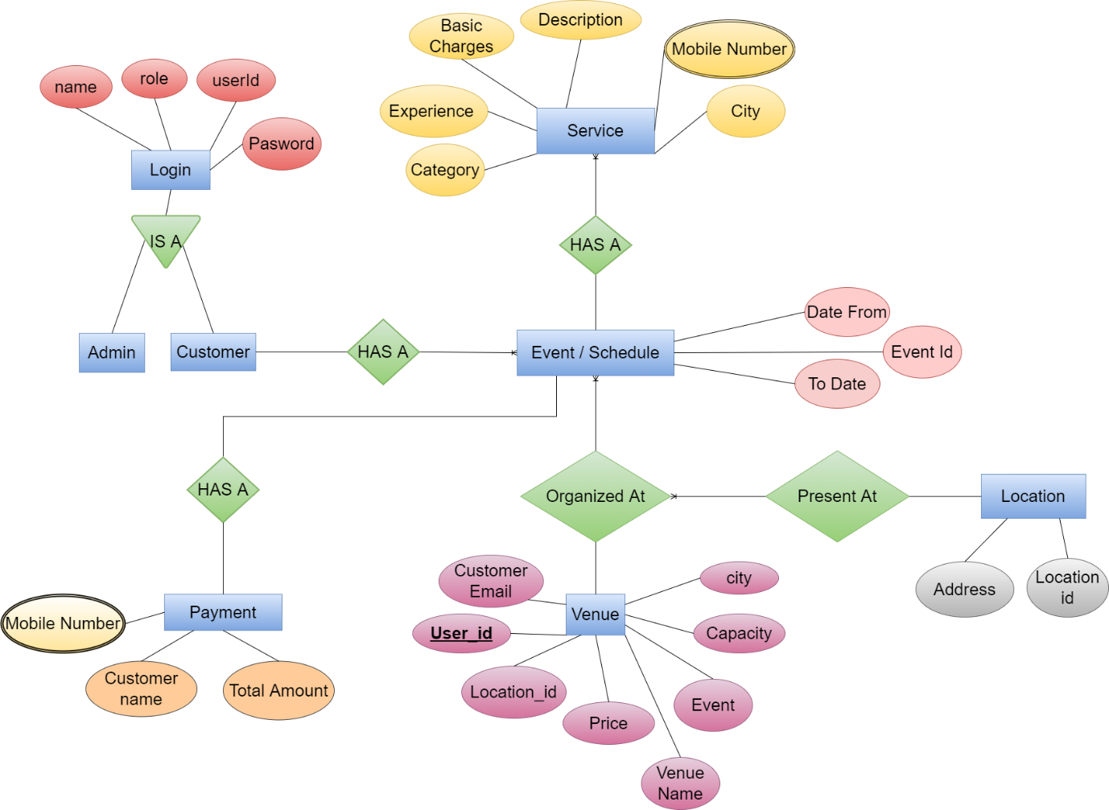

**DFD:-**

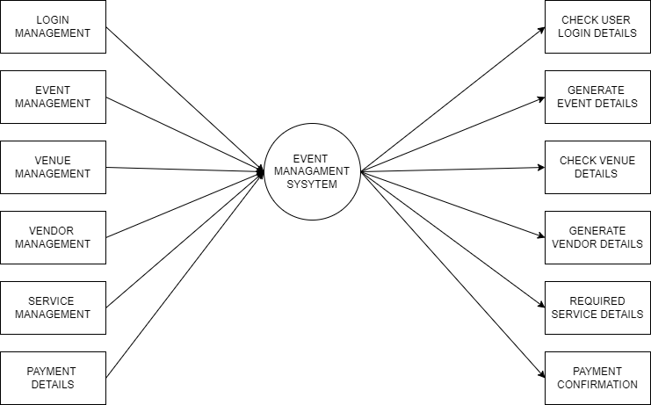

**Flowchart:-**

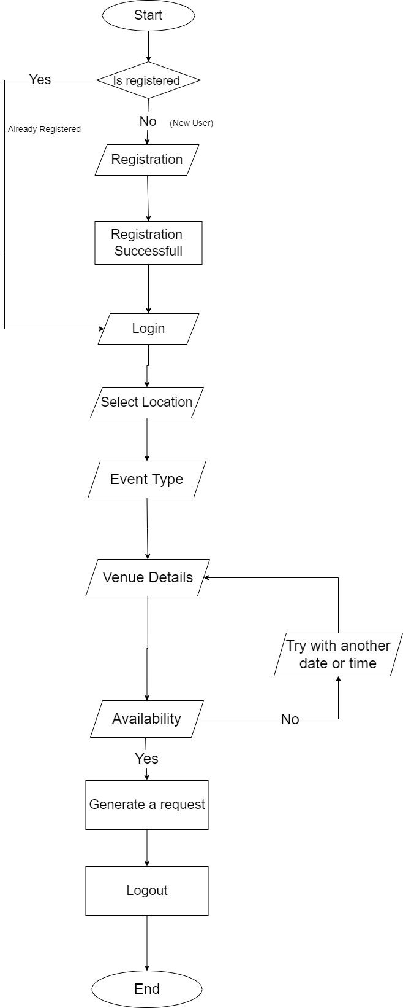

**Table Structure:-**

|  |  |  |
| --- | --- | --- |
| **Schedule** | | |
| Event Id | Int | PK |
| Date from | Date |  |
| Time | Int |  |

|  |  |  |
| --- | --- | --- |
| **Login Table** | | |
| Name | Varchar |  |
| Role | Varchar |  |
| User Id | Int | PK |
| Password | Varchar |  |

|  |  |  |
| --- | --- | --- |
| **Venue Table** | | |
| User id | int | PK |
| Location Id | Int | FK |
| Venue Name | Varchar |  |
| Customer Email | Varchar |  |
| Capacity | Int |  |
| Price | Double |  |
| City | Varchar |  |
| Event | varchar |  |

|  |  |  |
| --- | --- | --- |
| **Services** | | |
| Name | Varchar |  |
| Description | Varchar |  |
| Basic Charges | Double |  |
| Experience | Varchar |  |
| Category | Varchar |  |
| City | Varchar |  |
| Mobile no | varchar | CK |

|  |  |  |
| --- | --- | --- |
| **Payment Details** | | |
| Customer Name | Varchar |  |
| Total Amount | Double |  |
| Mobile Number | Varchar | CK |

|  |  |  |
| --- | --- | --- |
| **Location Table** | | |
| Location Id | Varchar | PK |
| Address | Varchar |  |